The Town of Medfield Energy Reduction Plan

Prepared by the Metropolitan Area Planning Council in coordination with the Town of Medfield & the Medfield Energy Committee

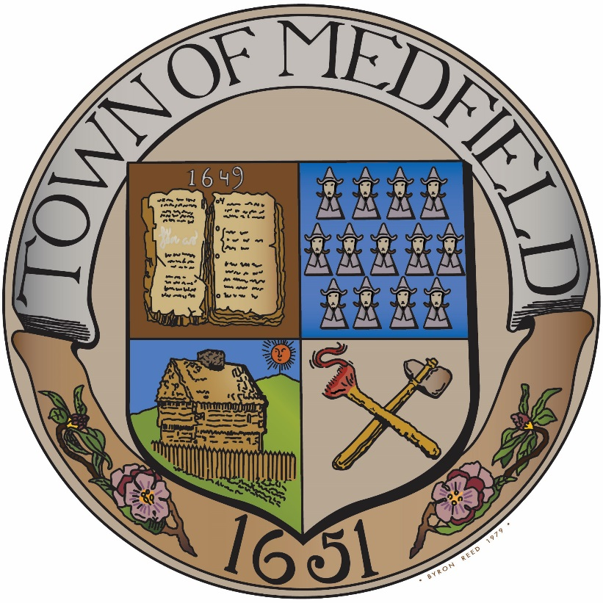

In fulfillment of the
Massachusetts Green Communities Grant Program Criterion 3

November 2016

Purpose and Acknowledgements
- Letters from Both the Town Administrator and the Superintendent Verifying Adoption of the ERP

- List of Contributors:

The collaborative efforts of many municipal stakeholders served to produce this energy reduction plan.

This plan was written by the Metropolitan Area Planning Council (MAPC), in coordination with Medfield municipal staff and the Medfield Energy Committee.
Much of the information in this plan was derived from energy audits performed by Rise Engineering (led by Sam Nutter), AECOM (led by Derrek Brown), municipal staff and Energy Committee members. Preliminary discussions regarding audit feasibility and coordination were advised by Eversource representative Steve Grattan and Columbia Gas representative Ernie Robinson. Additional resources and calculations were provided by the Fred Davis Corporation for streetlight measures and by MAPC for behavioral-based and fuel-efficient vehicle measures.

Table of Contents

I. Purpose and Acknowledgements 2
II. Executive Summary 5
III. Energy Use Baseline Inventory 7
IV. Energy Reduction Plan 14
V. Appendix A.: Town of Medfield Energy Audits – Rise Engineering 19
VI. Appendix B: Town of Medfield Energy Audits – AECOM 20
VII. Appendix C: Town of Medfield Energy Measures – Town of Medfield 21
VIII. Appendix D: Town of Medfield Energy Measures – MAPC 22
IX. Appendix E: Town of Medfield Streetlight Measures – Fred Davis Corporation 23
X. Appendix F: MMBTU Conversion Chart – DOER 24

Executive Summary
- Narrative Summary of the Town
The Town of Medfield is a Norfolk County community situated about 17 miles southwest of Boston. Medfield was first settled in 1649, and was officially incorporated in 1651. With an area of 14.4 square miles, Medfield has a population of 12,024 according to the 2010 Census. The Town is governed by a Board of Selectmen with Open Town Meeting.

- Green Communities Designation Progress

In 2008, the Medfield Board of Selectmen appointed an Energy Committee to look at the Town’s energy use, as well as residents’ and businesses’ energy use and explore energy efficiency solutions. With diligent work by Town Departments, energy use has declined 26% from 2008 through 2016. An objective of the Energy Committee since 2011 has been to qualify Medfield as a Department of Energy Resources (DOER) Green Community. To meet the Green Communities Criteria #1 &#2, a Solar By-Law was passed at the 2014 Town Meeting. In 2015, an Energy Efficient Vehicle Policy was adopted to meet Criterion #4. The Stretch Energy Code meeting Criteria #5 was adopted at the 2016 Town Meeting, leaving only the acceptance of a 5 year plan for energy reduction (Criterion #3) to meet all the necessary criteria to become a Massachusetts Green Community.

Criteria already met (as of Nov 3, 2016) | Designation Criteria | Description | Year of Adoption
✓ | Criterion 1 | Provide as-of-right siting in designated locations for renewable/alternative energy generation (or research & development, or manufacturing facilities) | 2014
✓ | Criterion 2 | Adopt an expedited application and permit process for as-of-right energy facilities | 2014
 | Criterion 3 | Establish an energy use baseline and develop a plan to reduce energy use by 20% within five years
✓ | Criterion 4 | Purchase only fuel-efficient vehicles | 2015
✓ | Criterion 5 | Set requirements to minimize life-cycle energy costs for new construction; one way to meet these requirements is to adopt the new Board of Building Regulations and Standards (BBRS) Stretch Code. | 2016

This document is Medfield’s 5 year plan for reducing energy usage by 20% or more. With the adoption by the School Committee and the Select Board, this Energy Reduction Plan, together with the documentation meeting the other four criteria will be submitted to DOER by or before November 21, 2016, so that that Town meets all requirements to become a Green Community.

This Energy Reduction Plan will serve as a basic blueprint to guide the Town’s energy efficiency activities through 2020, and may be subject to change. The plan will integrate with the Town’s Capital Improvements Plan, and together will be synergistic in meeting goals of efficiency, cost savings, and overall municipal building needs.

Energy Conservation Measures (ECMs) identified in this report and accompanying Table 4 spreadsheet, will require further engineering and cost analysis prior to procuring equipment and installation services.

- Summary of Municipal Energy Uses
- Total Number of Municipal Buildings: 14
- Total Number of Municipal Vehicles: 113
- Total Number of Street Lights and Traffic Lights: 347 streetlights and 6 traffic lights
- Water and Sewer: owned and operated by the Town of Medfield
- Wastewater Treatment Plant: 1
- Pumping and Flow Stations: 1 Water Pumping; 8 Sewer Pumping, 6 Sewer Flow

Table 1: Municipal Energy Use Summary
 | Number | Ownership
Buildings (14)
Oil Heat | 1
Natural Gas Heat | 10
Propane Heat | 1
Biomass Heat | 0
Other Heat Type | 0
Vehicles
Non-Exempt | 3
Exempt | 111
Street Lights | 347 | Eversource
Traffic Lights | 6 | Municipality
Water and Sewer
Wastewater Treatment Plant | 1 | Municipality
Water Pump Station | 1 | Municipality
Sewer Pump Stations | 8 | Municipality
Sewer Flow Stations | 6 | Municipality

- Summary of Energy Use Baseline and Plans for Reduction
Table 2b: Summary of Municipal Energy Use: Baseline Year FY 2015
Category | Energy Consumption in MMBTU (FY2015) | Weather Normalized Baseline Energy Use in MMBTU | % of Total Baseline Energy Consumption
Buildings | 45,369 | Weather Normalized Baseline Energy Use in MMBTU | 75.93%
Vehicles | 7,318 | Weather Normalized Baseline Energy Use in MMBTU | 12.25%
Street/Traffic Lights | 390 | Weather Normalized Baseline Energy Use in MMBTU | 0.65%
Water/Sewer/Pumping | 6,623 | Weather Normalized Baseline Energy Use in MMBTU | 11.08%
Open Space | 53 | Weather Normalized Baseline Energy Use in MMBTU | 0.09%
Total | 59,753 | 56,759 | 100.00%

Energy Use Baseline Inventory
- Identification of the Inventory Tool Used – The Town of Medfield used the Department of Energy Resources’ (DOER) MassEnergyInsight (MEI) web-based energy inventory and analysis tool.

- Identification of the Baseline Year – Fiscal Year (FY) 2015 will serve as the baseline year. FY 2015 ran from July 1, 2014 to June 30, 2015. This means that the Town aims to have a five-year plan for FY 2016 through FY 2020.

- Weather Normalization – The 20% energy reduction goal, per DOER’s requirements, will be measured using annual weather-normalized energy consumption data. However, weather-normalized data is only available at the overall Town consumption level, and not for individual facilities. Therefore, for the purposes of the analysis that follows in the document, non-weather-normalized data was used.

- Municipal Energy Consumption for the Baseline Year (FY 2015) – During the FY 2015 baseline year, the municipality used 59,753 MMBTUs of energy. The weather-normalized energy-use for FY 2015 is 56,759 MMBTUs

Table 2b: Summary of Municipal Energy Use: Baseline Year FY 2015 and Projected Energy Savings from selected Energy Conservation Measures (ECMs)
Category | Energy Consumption in MMBTU (FY2015) | Weather Normalized Baseline Energy Use | % of Total MMBTU Baseline Energy Consumption | Projected Planned MMBTU Savings | Savings as % of Total MMBTU Weather-Normalized Baseline Energy Consumption
Buildings | 45,369 | Weather Normalized Baseline Energy Use | 75.93% | 10,391 | 89.55%
Vehicles | 7,318 | Weather Normalized Baseline Energy Use | 12.25% | 994 | 8.57%
Street/Traffic Lights | 390 | Weather Normalized Baseline Energy Use | 0.65% | 218 | 1.88%
Water/Sewer/Pumping | 6,623 | Weather Normalized Baseline Energy Use | 11.08% | 0 | 0.00%
Open Space | 53 | Weather Normalized Baseline Energy Use | 0.09% | 0 | 0.00%
Total | 59,753 | 56,759 | 100.00% | 11,603 | 100.00%

In order to reach the Green Communities goal of reducing energy consumption by 20%, Medfield will need to reduce its overall weather-normalized energy consumption in FY2015 by 11,352 MMBTUs.
Table 3a and 3b present energy-use for each municipal facility in native units and MMBTUs.

Buildings: Medfield’s 14 buildings used 45,369 MMBTUs, around 75.9% of Medfield’s total municipal energy use. Among municipal buildings, school buildings made up 79.3% of energy consumption. The buildings with the greatest energy use is Medfield High School (14,030 MMBTUs), followed by Blake Middle School (8,766 MMBTUs).

Table 2c: Summary of Energy Use in Buildings: Baseline Year FY 2015
Buildings |  | Building Energy Consumption in MMBTU (FY2015) | % of Total Building Energy Consumption (FY2015)
School Buildings' Energy Consumption: | Medfield HS | 14,030 | 30.92% | 79.32%
School Buildings' Energy Consumption: | Blake MS | 8,766 | 19.32% | 79.32%
School Buildings' Energy Consumption: | Dale Street ES | 5,423 | 11.95% | 79.32%
School Buildings' Energy Consumption: | Memorial ES | 4,268 | 9.41% | 79.32%
School Buildings' Energy Consumption: | Wheelock ES | 3,497 | 7.71% | 79.32%
Non-School Buildings' Energy Consumption: | Town Garage | 5,983 | 13.19% | 20.68%
Non-School Buildings' Energy Consumption: | Medfield Public Library | 1,003 | 2.21% | 20.68%
Non-School Buildings' Energy Consumption: | Town Hall | 801 | 1.77% | 20.68%
Non-School Buildings' Energy Consumption: | Council on Aging: Center at Medfield | 639 | 1.41% | 20.68%
Non-School Buildings' Energy Consumption: | Police Dept | 604 | 1.33% | 20.68%
Non-School Buildings' Energy Consumption: | Fire Dept | 182 | 0.40% | 20.68%
Non-School Buildings' Energy Consumption: | Solid Waste | 107 | 0.24% | 20.68%
Non-School Buildings' Energy Consumption: | MEMA | 58 | 0.13% | 20.68%
Non-School Buildings' Energy Consumption: | Pfaff Center | 7 | 0.02% | 20.68%
 |  | 45,368 | 100.00% | 100.00%

New Construction:
In 2016, following the selected energy-use baseline year (FY2015), the Town of Medfield constructed a new Public Safety Building to replace its Police and Fire Station buildings listed in the baseline year. The new Public Safety will be operational in Fall 2016 and will have a gross square footage of 40,690 sq ft. This will replace the existing Police and Fire Station buildings’ gross square footage of 11,400 sq ft. Due to its larger size, this building will increase the Town’s energy load once it goes online.

Per consultation with DOER, the Town will incorporate this building stock change in its first annual report, after the building is in operation. For replacements of existing buildings, DOER requires that energy-use be apportioned according to the difference in square footage of the old and new building. “If the new building is larger than the replaced building, then the energy use will be apportioned according to the difference in their square footages. For example, if a 1000 sq foot building was replaced with a 1500 sq feet (an additional 33%), then 67% of the energy bills for the building would be accounted for in monitoring the community’s progress towards meeting its 20% energy reduction target.”

Street/Traffic Lights: There are 347 streetlights in Medfield. Additionally, Medfield has 6 traffic lights. Traffic and street lights consume 390 MMBTUs, 0.65% of the Town’s energy use.

Vehicles: Medfield’s 114 municipal vehicles use 12.3% of the baseline total, or 7,318 MMBTUs.

Water/Sewer Facilities: Water supply and waste water treatment consume 11% of total municipal energy consumption, or 6,623 MMBTUs. Medfield is serviced for wastewater by the Town. The Town also owns and operates drinking water wells and pumping stations. In 2016, following the selected energy-use baseline year, the Town of Medfield applied solar energy to its Wastewater Treatment Plant, which is expected to generate 300,000 kilowatt-hours of electricity a year and provide 40 percent of the plant’s yearly power consumption.
This renewable energy generation project at the Wastewater Treatment Plant will be complementary to the energy efficiency efforts of the Town, enhancing the Town’s overall sustainability activities. It is important to note, however, that the electricity generated at the Wastewater Treatment Plant will be considered a fuel source once operational, and should be included as a type of energy usage in future Green Communities annual reporting. The Massachusetts Department of Energy Resources (DOER) does not allow renewable energy projects to be used towards the 20% reduction for the Green Communities program.

- Energy Consumption for Baseline Year FY2015
The following tables illustrate detailed energy-use by facility.
Table 3a: Municipal Energy Consumption for Baseline Year FY 2015 (Native Units)

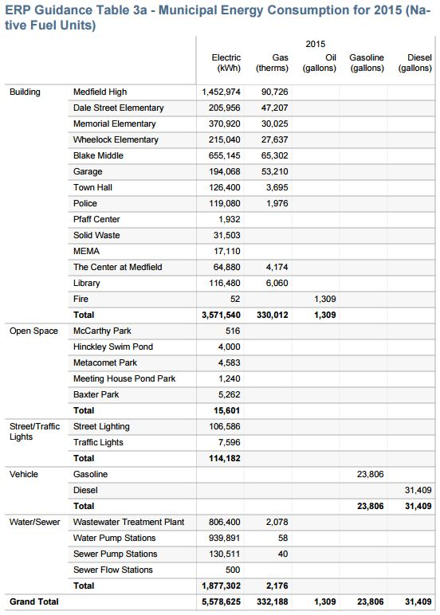
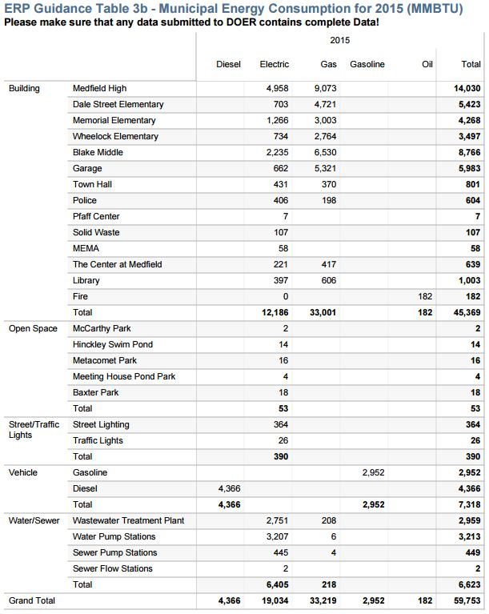
Table 3b: Municipal Energy Consumption for Baseline Year FY 2015 (MMBTU)

Energy Reduction Plan
- Narrative Summary

See the accompanying Table 4 in the attached Excel spreadsheet for the Energy Conservation Measures that the Town will pursue in order to achieve 20.44% energy consumption reductions in 5 years. Those measures are also listed below:
- Overview of Goals for Years 1-3:
- Two new boilers replaced end-of-life boilers at Wheelock Elementary School in Summer 2016, bringing the efficiency from 80% to 92%.
- Town Garage HVAC controls commissioning was completed in Spring 2016.
- Lighting retrofits were made at the Waste Water Treatment Plant in 2016.
- Interior and exterior lighting retrofits were made at the Council of Aging building, the Medfield Public Library and Town Hall are currently underway.
- Weatherization at Council of Aging building entrance is underway.
- Retrofit interior and exterior lighting with energy efficient fixtures and bulbs at Blake Middle School, Dale Street Elementary School, Medfield High School, Memorial Elementary School, Wheelock Elementary School and Town Hall (parking lights).
- Perform a comprehensive retro-commissioning of the EMS system at Medfield High School and Memorial Elementary School.
- Install Domestic Hot Water (DHW) measures such as low-flow aerators, spray valves and showerheads at Blake Middle School, Dale Street Elementary School, Medfield High School, Memorial Elementary School, Medfield Public Library, Town Hall, and Wheelock Elementary School.
- Insulate roof at time of roof replacement at Blake Middle School.
- Replace domestic hot water storage tanks with more efficient tanks at Blake Middle School.
- Implement a behavioral-based electricity-use reduction strategy at Blake Middle School and Medfield High School, in coordination with the administration, teachers, students and the facilities department.
- Install steam traps at Dale Street Elementary School.
- Conduct weatherization and HVAC upgrades at Medfield Public Library.
- Adopt a city-wide “No Idling” policy for all municipal vehicles.
- Incorporate a switch to 100% synthetic oil for all municipal vehicles’ oil replacement.
- Closely monitor vehicle tire air pressure to maintain vehicle fuel efficiency.
- Institute the use of a Digital Fleet Management System.
- Retrofit streetlights.

- Overview of Goal for Years 4-5:
- Retrofit interior lighting with energy efficient fixtures and bulbs at Medfield High School and Town Garage.
- Perform a comprehensive retro-commissioning of the EMS system at Blake Middle School and Town Hall.
- Install an EMS at Medfield Public Library.

- Path to 20% Energy Use Reduction by the end of Fiscal Year 2020
- Program Management Plan for Implementation, Monitoring, and Oversight
The Town Energy Committee, in collaboration with the Facilities Director, will be responsible both for oversight of the Energy Reduction Plan and for implementation of energy conservation measures within the Town. Medfield’s Energy Committee and Facilities Director, Gerard McCarty, will be responsible for the annual reporting requirements to maintain designation and eligibility for annual competitive grant funding.

In order to ensure progress in reaching the Town’s 20% goal, the Town will designate the Facilities Director, Gerard McCarty to develop a progress update to the Energy Committee every quarter and will update the Board of Selectmen and School Committee on progress annually. In addition, progress updates on the Energy Reduction Plan will be included in the Energy Committee’s annual report to the Board of Selectmen and Town Administrator.

The Town would also benefit from having a full- or part-time Energy Coordinator to execute these and other energy efficiency and renewable energy activities. The Energy Conservation Measures identified through the energy auditing process and those not yet realized could bring significant energy and cost savings to the municipality, and those annual cost-savings often exceed the salary needed for a full- or part-time energy coordinator.

DOER’s Energy Management Basic’s Report notes that “In some local governments, energy cost savings are: -put in the general fund, -returned to individual departments for their own use to encourage saving energy, or – used to fund more energy efficiency upgrades.”

- Summary of Energy Audit(s) or Other Sources for Projected Energy Savings
The attached spreadsheets and audit reports detail efficiency interventions that reduce overall municipal energy consumption by 20.44% over the next four to five years as identified by Rise Engineering, AECOM, the Town of Medfield, the Fred Davis Corporation, and MAPC.

References for each measure are cited in Table 4 and referenced reports are included as appendices to the Energy Reduction Plan. Projected MMBTU savings for each category (buildings, vehicles, street and traffic lights, water and sewer, and open space) are subtotaled to arrive at a municipal grand total of 11,603 MMBTUs.

Energy Management Systems across Municipal Facilities:
The Facilities Director will lead a comprehensive analysis on building controls across many municipal facilities, and will bring in a third-party to assess the functionality and effectiveness of existing energy management systems (software and hardware), as well as looking into needs for new energy management systems.
General Measures:
Other projects (not listed in Table 4) that the Town would like to further assess and pursue include:
- Weatherization (installed insulation and weather-stripping) of the Pfaff Center. Existing estimates anticipate annual energy savings of 160 MMBTUs and annual cost savings of $1,440.
- Roof replacement with insulation upgrades at Wheelock Elementary School.
- Energy-efficient window replacements at Wheelock Elementary School.
- Building Operator Certification (BOC) Training for the Facilities Director and/or future Energy Coordinator/Manager. Data shows that having a BOC certified operator can bring annual electricity savings of 100,500 kwhs and 1,400 therms.

- Street Lighting
The Town will develop a plan to purchase its 347 streetlights from Eversource. The price of purchase as stated by Eversource is $1 total. The plan to convert all lights to LED will be developed as the maintenance and repair options are clarified. This project will save the Town more than $35,000/year in energy costs.

- Summary of Long-Term Energy Reduction Goals – Beyond 5 Years
- Municipal Buildings (including schools)
To better strategize for the long-term maintenance and management of municipal buildings, Medfield will work with internal schools and Town staff as well as outside consultants, when necessary, to assess and document the condition of major municipal buildings on an annual basis. In addition to exposing continuing opportunities for energy use reductions, this effort will provide the Town with a clear, long-term asset management strategy for the effective budgeting and maintenance of buildings.

Additionally, the Town could take the following measures for municipal buildings:
- Adopt a Certified Green Building Standard (e.g., LEED Silver or Gold, Living Building Challenge) as the design and construction minimum for the renovation and new construction of all municipal facilities, and
- Implement a routine load-shedding program whereby peak demand energy use is reduced and operational changes are instituted (e.g. higher AC set points in summer, consolidated facility use during off-hours) to lessen overall energy demand year-round.

- Vehicles (including schools)
The Fuel-Efficient Vehicle policy will have become engrained within municipal purchasing practices after 5 years, and the Town will seek to explore even more efficient policies and tracking systems to enable more efficiency.

- Perpetuating Energy Efficiency
An annual municipal audit by Town and Schools staff can tap into the knowledge of the employees who use and maintain the building every day. It can empower building staff to develop a detailed repair and management schedule and collect data on problems and inefficiencies that may be missed by traditional third party audits. Web-based application systems such as See Click Fix can be considered to create additional real-time opportunities for efficiencies in operation and maintenance.

The Town of Medfield will grow its capacity to retrofit and build more efficient facilities, purchase more efficient vehicles, and illuminate the Town through more efficient lighting throughout the 5-year period. These practices will become more engrained in the culture of the Town and will provide opportunities to instill the ethos into additional policies and programs for more dedicated long-term funding streams and strategies.

Appendix A.: Town of Medfield Energy Audits – Rise Engineering

Appendix B: Town of Medfield Energy Audits – AECOM

Appendix C: Town of Medfield Energy Measures – Town of Medfield

Appendix D: Town of Medfield Energy Measures – MAPC

Appendix E: Town of Medfield Streetlight Measures – Fred Davis Corporation

Appendix F: MMBTU Conversion Chart – DOER
MMBTU Conversion Chart

Fuel Energy Content of Common Fossil Fuels per DOE/EIA
BTU Content of Common Energy Units – (1 million BTU equals 1 MMBTU)
- 1 kilowatt hour of electricity = 0.003412 MMBTU
- 1 therm = 0.1 MMBTU
- 1 ccf (100 cubic foot) of natural gas = 0.1028 MMBTU (based on U.S. consumption, 2007)
- 1 gallon of heating oil = 0.139 MMBTU
- 1 gallon of propane = 0.091 MMBTU
- 1 cord of wood = 20 MMBTU
- 1 gallon of gasoline = 0.124 MMBTU (based on U.S. consumption, 2007)
- 1 gallon of E100 ethanol = 0.084 MMBTU
- 1 gallon of E85 ethanol = 0.095 MMBTU
- 1 gallon of diesel fuel = 0.139 MMBTU
- 1 gallon of B100 biodiesel = 0.129 MMBTU
- 1 gallon of B20 biodiesel = 0.136 MMBTU
- 1 gallon of B10 biodiesel = 0.137 MMBTU⁷
- 1 gallon of B5 biodiesel = 0.138 MMBTU⁷
- 1 barrel of residual fuel oil = 6.287 MMBTU

http://www.mass.gov/eea/docs/doer/green-communities/ems/energy-basics-7-15-13-update.pdf
http://www.theboc.info/wp-content/uploads/2015/09/BOC-Energy-Savings-FAQ-2015.pdf
If a conversion factor for a fuel you use is not provided, please contact DOER.
Calculated Values from those of diesel and B100 biodiesel

